**Work-case 7**

1. In the course of work, the task of planning tasks often arises:

- Describe the main functions that the task scheduler can perform in any OS. Compare the possibilities of scheduling tasks in different OS using the example of Windows and Linux.

- Describe the basic principles of working with the Cron scheduler in the Linux OS. How to configure it? Are there alternatives to it (give their description).

2. For your Linux virtual machine, schedule the tasks of your choice (start applications, power on/off the machine, clean directories, delete files, backup, archive, etc. of your choice) via the Cron scheduler:

- Completing the planned task at a time clearly defined by you (for example, at 8 a.m., 6:30 p.m., etc.).

- Performing the same task twice a day (you also determine the time yourself).

- Performing the same task only on weekdays (or only on weekends) during a clearly defined period of time (for example, from 8 a.m. to 6 p.m.).

- Execution of tasks only once a year, once a month, once a day, every hour, at power-on (after reboot).

3. Install an alternative Cron task scheduler (of your choice). Demonstrate the actions performed in task 2 through it.  
  
**Task 1.**

The main functions of task schedulers:

Execution of programs/scripts at a certain time or according to a schedule: Automating the launch of tasks at a certain point in time or according to a certain schedule.

Automatic execution of regular operations: Schedulers allow you to automate repetitive operations such as backups, cleaning, etc.

System events and triggers: Some schedulers can respond to system events or triggers, such as the completion of a task or a change in system state.

Comparison of task scheduling capabilities in Windows and Linux:

Windows Task Scheduler:

Integrated into Windows.

It has a graphical interface.

Supports different types of triggers and actions.   
Can be used for remote control.

Cron in Linux:

Integrated into most Linux distributions.

Uses text configuration files.

Flexible settings and powerful capabilities.

Easy to use, but does not have a graphical interface.

Basic principles of working with the Cron scheduler in the Linux OS:

Cron settings:

The crontab -e command is used to edit the crontab file.

Lines are added that specify the time and the command to execute.

Alternatives:

Alternatives include systemd timers, anacron, fcron.

Each of them has its own features and capabilities, but Cron is the standard for most Linux systems.

**Task 2.**

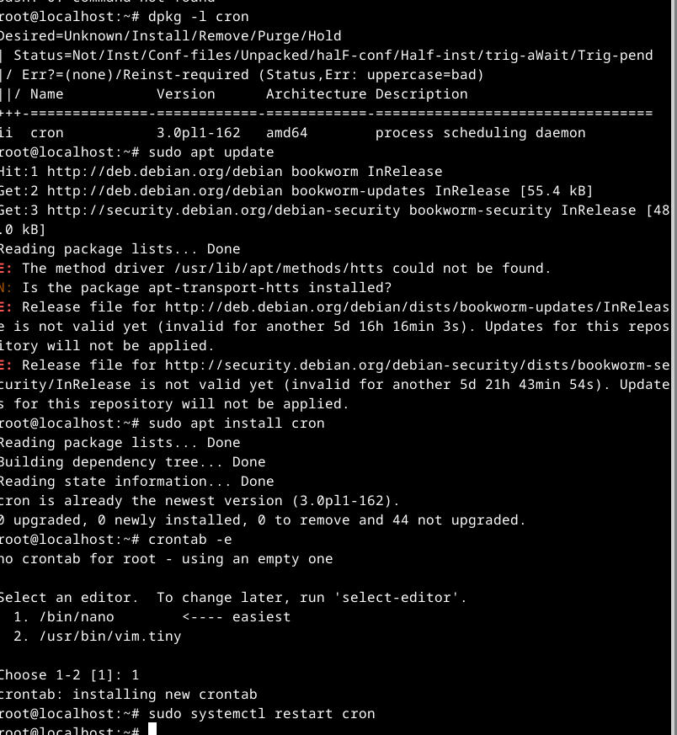

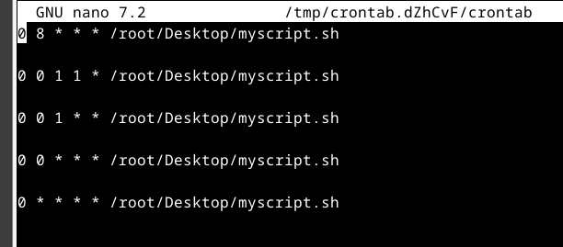

**Task 3.**

